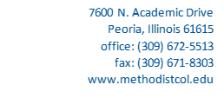

Formal Complaint Submission Form

Complainant (student name): Click or tap here to enter text.

Respondent (against whom the complaint is directed): Click or tap here to enter text.

Date of Violation: Click or tap to enter a date.

Code/Policy/Regulation Violated: Click or tap here to enter text.

Narrative (Detail pertinent information regarding violation including any aspects of the informal complaint process which may have occurred): Click or tap here to enter text.

Desired Outcome/Sanction: Click or tap here to enter text.

Supporting Materials: Click or tap here to enter text.

